Computational Methods
Name:
Institution

Table of Contents
Introduction………………………………………………………………………………………..1
Task …………………………………………………………………………………………….2
Material properties ....................................................................................................................3
Theory Calculation………………………………………………………………………………..4
Modelling Structural.....................................................................................................................5
Methodology Calculations………………………………………………………………………6
Discussion Results.....................................................................................................................7
Task 2 ......................................................................................................................................8
Theory: .....................................................................................................................................9
Deflection (m): ....................................................................................................................10
Moment (N*m): .................................................................................................................11
Stress 𝝈𝒚 (𝑷𝒂) …………………………………………………………………………………12
Stress 𝝈𝒚 (𝑷𝒂) near center…………………………………………………………………..13
Shear stress (𝝉) (Pa)………………………………………………………………………………..14
Conclusion………………………………………………………………………
Reference………………………………………………………………………………………

Introduction

Finite element analysis (FEA) is a computerized approach for calculating how a product responds to real-world forces, vibration, heat, fluid float, and different physical consequences. FEA displays whether products will disruption, wear out, or paintings the manner it became designed. It’s miles called analysis, but in the product development manner, it is used to calculate what's going to show up when the product is used. to use FEA for simulation of the product, ANSYS is software used by engineers to layout and simulate based totally on mathematical given. FEA works with the aid of disruption out an actual item into a big amount of finite factors, including little cubes. Mathematical equations assist to calculate the performance of each detail. A computer then adds up all the man or woman behaviors to calculate the behavior of the real item. Task 1 will conduct approximately the modeling and simulation of the flat plate and beam model by means of the use of different element sorts and examine the effects theoretical and numerical.
- Task 1
Solution
Stresses in Beams
On this task we will research and examine the facts of the flat plate that's one end completely fixed as consistent with given figure 1 below, form of fabric is stainless-steel (AISI 302) cold rolled. Thickness of the plat is 8mm and load applied at the right side is 10 MPa. We assumed it’s a plan strain stress, permits locate stress attention thing. Noting that, we will make use of exceptional density of meshes, 200, 400, 800, 1600.
We need to look what the impact of pressure for the beam which is absolutely fixed from one side and how to see that from distinctive type of mesh. In addition look at the impact strain on the beam via Appling one-of-a-kind detail size to discern out the pressure on the pointed load on the beam. Anything detail size change, maximum pressure must be changed too.
2.1 Material properties
Material properties |  |  | T (°C)
Density (×1000 kg/m3) | 8 |  | 25 | Conditions
Poisson's Ratio | 0.27-0.30 |  | 25 | Treatment
Elastic Modulus (GPa) | 193 |  | 25
Tensile Strength (Mpa) | 086 |  | 25 | hot finished and annealed (wire)
Yield Strength (Mpa) | 205
Elongation (%) | 40
Reduction in Area (%) | 50
Hardness (HRB) | 88 (max) |  | 25
Hardness (HRB)
 |  |  |  |  | annealed (plate, sheet, strip)

  - Theory Calculation:
Calculating the stress concentration factor;
𝐷 = 40, 𝑑 = 20 , 𝐴 = 1.13390,
𝑏 = −0.38586 𝐾𝑡ℎ = 𝐴 ∗ ( 𝑑 )
𝑏 = 1.13390 ∗ (10 20) −0.38586
= 1.481597339
Stress maximum of theory.
𝐾𝑡ℎ = 𝜎𝑚𝑎𝑥 𝜎𝑎𝑣𝑔 ,
𝜎𝑎𝑣𝑔 = 10
𝑃𝑎 σmax = kth ∗ σavg
= 1.481597339 ∗ 10 = 14.8160 Pa
  - Modelling Structural:
Centered on the drawing above, structural and modelling of the plat is created by using different mesh elements to determine maximum and minimum stress by each number of meshes given from the task.

  - Methodology Calculations:
For the table 1 below, is to show the result of stresses (maximum, minimum and average) that I got from ANSYS software to get result of concentration factor of finite element (𝐾𝐹𝐸), then to compare the results theoretical and numerical by calculating error percentage.
𝜎𝑎𝑣𝑔 = 𝜎𝑚𝑎𝑥−𝜎𝑚𝑖𝑛 2,
𝐾𝐹𝐸 = 𝜎𝑚𝑎𝑥 𝜎𝑎𝑣𝑔 ,
𝐸𝑟𝑟𝑜𝑟% = 𝐾𝐹𝐸−𝐾𝑡ℎ 𝐾𝑡ℎ
Figure | 𝐸𝑡ℎ | 𝐸𝐴𝑁𝑆𝑌𝑆 | 𝜎𝑚𝑎𝑥 | 𝜎𝑚𝑖𝑛 | 𝜎𝑎𝑣𝑔 | 𝐾𝐹𝐸 | Error%
1 | 200 | 246 | 23.531 | 3.1257 | 10.2027 | 2.3064 | 55.7%
2 | 400 | 416 | 25.829 | 2.3808 | 11.7241 | 2.2031 | 48.7%
3 | 800 | 780 | 28.744 | 1.0605 | 213.8418 | 2.0766 | 40.2%
4 | 1600 | 1602 | 29.269 | 0.76232 | 14.2533 | 2.0535 | 38.6%

  - Discussion Results:
For instance: For the mesh element two hundred as in line with given from the project, I were given close quantity of mesh from ANSYS that is 264. As consistent with result from the ANSYS of minimum and most pressure three.1257 and 23.531 respectively; The common stress is the quantity of maximum strain minus minimum stress divided by 2, it given 10.2027. To get concertation element (𝐾𝐹𝐸), it became divided maximum stress with the aid of average stress for the mesh 2 hundred, I were given 2.3064. To give an explanation for approximately mistakes % we calculated 𝐾𝐹𝐸 theoretical as proven here, the pressure become implemented in each facet left and right. However, in return the geometry we've got used as in step with required changed into from one facet fixed whilst the theoretical awareness factor calculation the stress applied changed into from both side.

Task 2
In this assignment, we are going to investigate a beam left give up fully fixed and right quit supported. Period of the beam is 250mm along X-axis, 13mm an extended Z-axis, 6mm along Y-axis. The applied downward to the beam n = 773 KPa.
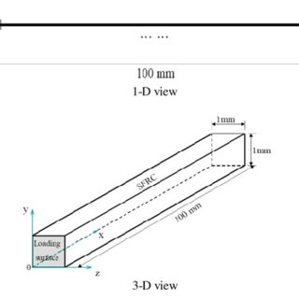
First of all the calculation will be in theory part in order to refer it and compare the calculation with theory and the ANSYS simulation to analyze the difference.
Element type | Deflection  (m) | Moment  (N.m) | Shear  (N) | Q_{y}  (Pa) | Q_{y}  (Pa)  (Near center) | Q_{y}  (Pa)
1st Plate Model | 0.0022 | 36.234375 | 724.6875 | 4.65 × 10⁸ | 2.32 × 10⁸ | 1.21 × 10⁸
2nd Plate Model | 0.0047 - - | 8.829 × 10⁸ | - | - | 4.98 × 10⁸ | 8.28 × 10⁷
Brick | 0.0146 - - | - | - | 3.58 × 10⁹ | 2.025 × 10⁹ | 2.62 × 10⁻⁸
Theoretical | 0.0036 - - | - | - | 8.258 × 10⁸ | 4.71 × 10⁸ | 9.47 × 107

3.1 Theory: The given data:
3.1.1 Deflection (m): ∆𝑚𝑎𝑥 = 𝑤∗𝑙 4 185∗𝐸∗𝐼
= 4638∗(0.25) 4 185∗1.9∗1011∗2.34∗10−10
= 2.2026 ∗ 10−3 (𝑚)
= 0.0022026 (𝑚) 3.1.2 Moment (N*m): 𝑀𝑚𝑎𝑥
= 𝑤 ∗ 𝑙 2 8 = 4638 ∗ (0.25) 2 8
= 36.234 (𝑁 ∗ 𝑚) Figure 1 𝒃 = 𝟎. 𝟎𝟏𝟑 ,
𝒅 = 𝟎. 𝟎𝟎𝟔 ,
𝒍 = 𝟎. 𝟐𝟓,
𝑷 = 𝟕𝟕𝟑 𝑲𝑷𝒂,
𝑬 = 𝟏𝟗𝟎𝑮𝑷𝒂 𝒘 = 𝑷 ∗ 𝒕 = 𝟕𝟕𝟑𝟎𝟎𝟎 ∗ 𝟎. 𝟎𝟎𝟔 = 𝟒𝟔𝟑𝟖 𝑷𝒂. 𝒎 𝑰 = 𝒃 ∗ 𝒅 𝟑 𝟏𝟐 = 𝟎. 𝟎𝟏𝟑 ∗ (𝟎. 𝟎𝟎𝟔) 𝟑 𝟏𝟐 = 𝟐. 𝟑𝟒 ∗ 𝟏𝟎−𝟏𝟎 𝒎�
3.1.3 Shear force
(N): 𝑉𝑚𝑎𝑥 = 𝑉2 = 𝑅2 = 5 ∗ 𝑤 ∗ 𝑙 8 = 5 ∗ 4638 ∗ 0.25 8 = 724.6875 (𝑁)
3.1.4 Stress 𝝈𝒚 (𝑷𝒂) : 𝑦 = 0.006 2 = 0.003 𝑚 𝑀𝑚𝑎𝑥 = 𝑤 ∗ 𝑙 2 8 = 4638 ∗ (0.25) 2 8 = 36.234375 𝑁. 𝑚 𝜎𝑚𝑎𝑥 = 𝑀𝑚𝑎𝑥 ∗ 𝑦 𝐼 = 36.234 ∗ 0.003 2.34 ∗ 10−10 = 4.65 ∗ 108 𝑃𝑎 3.1.5 Stress 𝝈𝒚 (𝑷𝒂) near center: 𝑀𝑥 = 𝑅1 ∗ 𝑥 − 𝑤 ∗ 𝑥 2 2 , 𝑅1 = 3 ∗ 𝑤 ∗ 𝑙 8 = 3 ∗ 4638 ∗ 0.25 8 = 434.8125 𝑁 𝑀𝑋0.125 = 𝑅1 ∗ (𝑥0.125)− 𝑤 ∗ (𝑥0.125) 2 2 𝑀𝑋0.125 = (434.8125 ∗ 0.125) − 4638 ∗ (0.125) 2 2 = 18.1171875 𝑁 ∗ 𝑚 𝜎𝑛𝑒𝑎𝑟 𝑡ℎ𝑒 𝑐𝑒𝑛𝑡𝑟𝑒 = 𝑀𝑋0.125 ∗ 𝑦 𝐼 = 18.117187 ∗ 0.003 2.34 ∗ 10−10 = 2.32 ∗ 108 𝑃𝑎
3.1.6 Shear stress (𝝉) (Pa):
𝐴 = 𝑏 ∗ 𝑑 = 0.013 ∗ 0.006 = 0.000078 (𝑚2 )
𝑡 = 0.006 (𝑚) 𝑄 = 𝐴 ∗ 𝑡 = 0.000078 ∗ 0.006 = 0.000000234 (𝑚3 )
𝜏 = 𝑣𝑚𝑎𝑥 ∗ 𝑄 𝐼 ∗ 𝑡 = 𝑣𝑚𝑎𝑥 ∗ 𝐴 ∗ 𝑡 𝐼 ∗ 𝑡 = 724.6875 ∗ 0.000078 2.34 ∗ 10−10 = 2.41 ∗ 108 (𝑃𝑎)
The longitudinal traces in a beam may be decided with the aid of analyzing the curvature of the beam and the related deformations. because of this, bear in thoughts a detail AB of a beam in herbal bending subjected to 2927099c7129e5e67b031f9eb65b6349 bending moments M. expect Refer to the figures below are the results that I got from ANSYS software based on my results given to find out the design of each Element Types required.
3.2 1st Plate Element Model, 250mm X 13mm dimension, thickness 6mm.

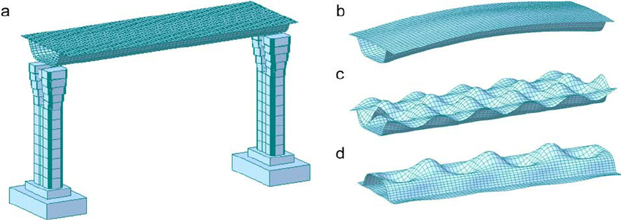
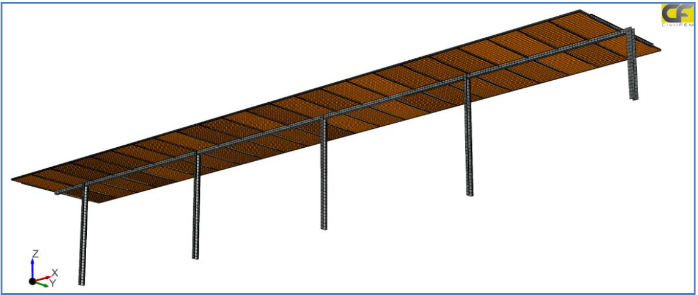

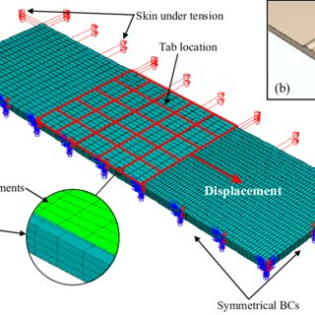
3.5 Description:
For the Beam model because the mesh size growth the accurate result is regardless the boom or lower inside the strain. Then again the maximum strain and deflection are without delay proportional the greater most stress is the more deflection boom. but, if the stress and deflection are increasing the shear stress will lower concluding that it’s inverse dating. in the end, evaluating the result with theoretical in first plate the stress is applied 773 KPA on the area which motive the deflection high due to less thickness evaluate with others and strain is excessive and the shear strain much less, at the second plate the force is carried out on the edge which makes the value large distinction evaluate with 1 st plate and the
deflection and stress is better than others and the shear stress very less and we will say it’s almost 0.In 3-D version the design became amassing the first and 2nd plate and the result calculated from simulation become close to the theoretical because of pressure carried out to the place which has the thickness.
• Notice: second and shear force are not applicable values on ANSYS software.
Modal analyses have been completed on above plate and beam fashions to decide their herbal frequencies and mode shapes during unfastened vibration. it is common to apply the FEA to perform this assessment and the influences of the detail duration at the modal assessment consequences are mentioned right here. on this observe, exceptional the lowest frequencies are listed and in assessment for each model due to the fact the bottom frequencies are associated with the maximum ="disguise">extraordinary="tipsBox"> modes at which the model will vib="hide">first="tipsBox">, dominating all of the special higher frequency modes. In performing the modal assessment, the metal plate has become limited on its short side and the skinny-walled metallic beam modified into confined at its stop.
In conclusion, in this have a have a look at the consequences of element period on accuracy of finite element fashions and simulation results have been very well investigated through static assessment, effect evaluation, and modal assessment. It modified into located that for static analysis that assumes steady loading and reaction conditions, each facet of a plate model need to be discretized into 10 divisions an terrific manner to accumulate satisfied effects (with approximation errors < 1% in our instance) consuming tons a great deal much less laptop assets and computing time. For impact assessment which includes speedy, temporary loading and considers dynamic structural response, a skinny-walled beam version wants to be meshed into 80 divisions alongside its axis as a way to simulate its crash response correctly and correctly (with approximation errors < 10%).For modal assessment, the selection of the great element duration isn't always very urgent because of the truth (1) the FEA fashions with less big range of factors can efficiently expect the herbal frequencies (with approximation mistakes < 1%) and (2) even the FEA fashions with splendid mesh rate no extra than 20 seconds to finish a modal assessment. despite the fact that, it is advocated to exercising 10divisions on the field beam models to effectively simulate their mode shapes in lowest herbal frequencies.
The furnished outcomes show that particular forms of structural evaluation require appropriate mesh era schemes. The splendid mesh density for static, impact and modal evaluation can be used as suggestions in developing one-of-a-kind finite element models for structural evaluation, with a purpose to result in correct and inexperienced laptop simulations. One deficiency of this take a look at is that the authors did not expand mathematical fashions to visually display the relationships among detail length, accuracy of effects, and computing time for particular analyses. this is because of the fact that during any kind of assessment, multiple form of give up quit result can be extracted and studied (this paper fine lists some type of effects as an instance). As examined in the paper, the detail period has unique have an impact on on one-of-a-type kinds of results. therefore, it's miles neither feasible nor vital to derive mathematical fashions for every shape of end result to show the impacts of the detail period. each exclusive shortcoming of the FEA models provided in this paper is that the ones models use automated mesh most effective. superior mesh strategies together with adaptive mesh are not taken into consideration.
Element Type Deflection (m) Moment (N.m) Shear (N) 𝜎𝑦 (Pa) 𝜎𝑦(Pa) (near center) 𝜏𝑦𝑧 (Pa) Theoretical 0.0022 36.234375 724.6875 4.65 × 108 2.32 × 108 1.21 × 108 1 st plate element 0.0047 - - 8.829 × 108 4.98 × 108 8.28 × 107 2 nd plate element 0.0146 - - 3.58 × 109 2.025 × 109 2.62 × 10−8 Brick 0.0036 - - 8.258 × 108 4.71 × 108 9.47 × 107

Conclusion
Based totally on the above result and simulation, ANSYS can resolve the complex layout geometry for engineers and computing the technique required. Today, engineers use computers and software within the layout and manufacture of maximum products, tactics and structures. Finite detail analysis (FEA) is one of the maximum essential tools in an engineer or designers. In assignment 1 it was required to layout and simulate a good way to calculate the strain awareness factor and to evaluate it with theoretical which changed into discovered there are mistakes due to ok of ANSYS became higher than theoretical due to the ANSYS version goes via information in geometry. alternatively, the project 2 become to research beam model through the use of unique version geometry and it been determined that the effect of deflection and strain are directly proportional while the shear stress is inversely proportional and the fee of brick deflection version become near the theoretical because of extra thickness.

References
Conclusion in Finite Element Analysis - Machine Vice Analysis - folio. 2019. Conclusion in Finite Element Analysis - Machine Vice Analysis - folio. [ONLINE] Available at: https://folio.brighton.ac.uk/artefact/artefact.php?artefact=176395&view=31898. [Accessed 04 January 2019].
Finite Element Analysis Software | Autodesk. 2019. Finite Element Analysis Software | Autodesk. [ONLINE] Available at: https://www.autodesk.com/solutions/finite-elementanalysis. [Accessed 04 January 2019].
Introduction to Finite Element Analysis . 2019. Introduction to Finite Element Analysis . [ONLINE] Available at: https://www.asme.org/products/courses/introduction-to-finiteelement-analysis. [Accessed 04 January 2019].

